**Information Architecture**

**Victoria Wight**

**001175210**

Stakeholder Objectives:

The topic I am doing is endangered species in Alberta. I would like to raise awareness on the wildlife in our province and shed light on the dangers of not reversing the damage done to their habitat or human interference such as hunting illegally.

User Profile:

The user could be a person looking to learn more about animals and how they can help them from going extinct. A student may use it to visualize the information in an easy to understand matter.

Content Inventory:

I would like to do a page for each of the categories of animals: Amphibians, Birds, Fish, Mammals and Reptiles in one dropdown menu. Then there will be a menu on information about endangered species, what is causing their decline, further information and a reference page.

Timeline:

Preliminary Concept Development

Endangered species in Alberta, the different types of animals, the different species.

Website Map:

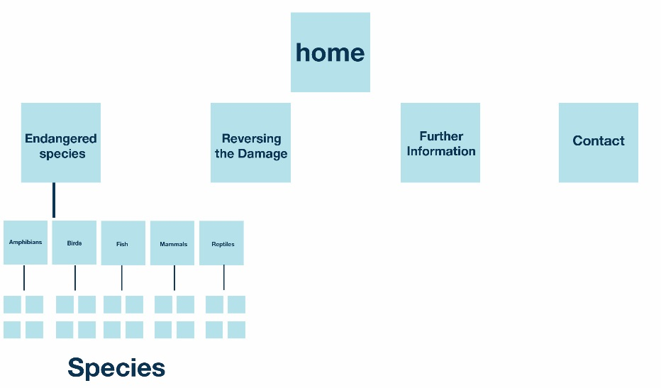

Links:

<http://aep.alberta.ca/fish-wildlife/species-at-risk/species-at-risk-publications-web-resources/default.aspx>

<http://aep.alberta.ca/fish-wildlife/species-at-risk/species-at-risk-publications-web-resources/amphibians/default.aspx>

<http://aep.alberta.ca/fish-wildlife/species-at-risk/species-at-risk-publications-web-resources/birds/default.aspx>

<http://aep.alberta.ca/fish-wildlife/species-at-risk/species-at-risk-publications-web-resources/fish/default.aspx>

<http://aep.alberta.ca/fish-wildlife/species-at-risk/species-at-risk-publications-web-resources/mammals/default.aspx>

<http://aep.alberta.ca/fish-wildlife/species-at-risk/species-at-risk-publications-web-resources/reptiles/default.aspx>

<https://moodle.uleth.ca/201601/pluginfile.php/81850/block_html/content/SpeciesAtRiskGuide-Jan-2015.pdf>